SARVIKA TECHNOLOGIES
Hospital Management System
User Acceptance Testing (UAT) Document
Version 1.0 | Phase 1 Modules | April 2026

Product | HMS — Hospital Management System
Version | Phase 1 (v1.0)
Prepared by | Sarvika Technologies
Test Environment | https://hms-frontend-ebon-sigma.vercel.app
Backend API | https://api.sarvikatech.in/api/v1
Test Date | April 2026
Document Status | Ready for UAT

How to Use This Document
This document is your complete guide to testing the HMS before go-live. Each section covers one module. For each test case:
- Follow the steps exactly as written
- Mark Status as Pass / Fail after testing
- Write any observations or bugs in the Notes column
- A test is complete only when ALL cases in a module pass

Login credentials for testing:
URL | https://hms-frontend-ebon-sigma.vercel.app
Email | admin@mbshospital.com
Password | Admin@123!
Role | ADMIN (full access to all modules)

Module 1 — Authentication & Login
Tests that staff can securely log in and out. Verifies role-based access and security controls.

TC# | Test Case | Steps | Expected Result | Status | Notes
1.1 | Successful login with valid credentials | Open app URL. Enter email: admin@mbshospital.com, Password: Admin@123!. Click Sign in. | Redirected to Dashboard. User name shows in sidebar. Role shows as Admin. | User name is Shown as MBS HMS. | This needs to be different for different users – personalized – the Name
1.2 | Failed login with wrong password | Enter correct email but wrong password. Click Sign in. | Error message appears: 'Invalid email or password'. User stays on login page. | OK | OK
1.3 | Failed login with wrong email | Enter a non-existent email and any password. Click Sign in. | Error message appears. User stays on login page. | OK | OK
1.4 | Rate limiting on login | Enter wrong password 5 times in a row. | After 5 attempts, message: 'Too many login attempts. Please wait 15 minutes.' | Couldn’t test - Skipped
1.5 | Password field masking | On login page, type in the password field. | Password shows as dots. Eye icon toggles visibility. | OK | OK
1.6 | Session persistence | Log in. Close browser tab. Reopen the app URL. | User remains logged in without re-entering credentials. | OK | OK
1.7 | Logout | Click the logout icon (arrow) next to username in sidebar bottom. | User is logged out and redirected to login page. Session is cleared. | OK | OK
1.8 | Unauthorized access redirect | Log out. Try to access /dashboard directly in browser URL. | Automatically redirected to /login page. | OK | OK
1.9 | View current user profile | After login, the sidebar shows user name and role at the bottom. | Name and role match the logged-in account. | OK | The font color can be made white – it’s less readable right now

Module 2 — Patient Management
Tests patient registration with DPDPA-compliant consent capture, patient search, and profile viewing.

2A — Patient Registration
TC# | Test Case | Steps | Expected Result | Status | Notes
2.1 | Register new patient with all mandatory fields | Click Patients > Register patient. Fill: Name (Test Patient), Phone (9876543210), Gender (Male), Blood group (B+). Tick consent checkbox. Click Register. | Success message. Patient created with unique UHID (MBS-2026-XXXXX). Redirected to patient profile. | OK | Can we make this field as drop-down like blood group: “State”
2.2 | DPDPA consent is mandatory | Fill all patient details but do NOT tick the consent checkbox. Click Register. | Error: 'Patient consent is required to register.' Button stays disabled without consent. | OK | OK
2.3 | Duplicate phone number validation | Try to register a new patient with same phone number as an existing patient. | Error message: 'A record with this phone already exists.' | FAIL | 2 Patients with same phone number got saved  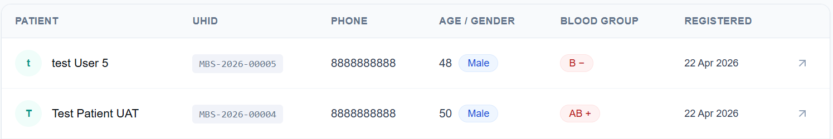
2.4 | Invalid phone number validation | Enter a phone number starting with 1 (e.g. 1234567890). Click Register. | Validation error: 'Valid Indian mobile number required.' | OK | OK
2.5 | Register patient with ABHA number | Fill patient details. Add ABHA number in the designated field. Register. | Patient saved with ABHA number visible in profile. | OK | OK
2.6 | Register patient with emergency contact | Fill patient details including Emergency contact name and phone. Register. | Emergency contact appears in patient profile overview tab. | OK | OK
2.7 | Register patient with known allergies | Fill patient details. Enter 'Penicillin' in allergies field. Register. | Patient profile shows allergy warning with red alert icon. | OK | OK

2B — Patient Search & Profile
TC# | Test Case | Steps | Expected Result | Status | Notes
2.8 | Search patient by name | Go to Patients. Type part of a patient name in the search box. | Matching patients appear in the list instantly. | OK | OK
2.9 | Search patient by UHID | In search box, enter the full UHID (e.g. MBS-2026-00001). | Exact patient appears in results. | OK | OK
2.10 | Search patient by phone number | In search box, enter the patient's phone number. | Correct patient appears in results. | OK | OK
2.11 | View patient profile — overview tab | Click any patient from the list. | Profile opens showing: UHID, age, gender, blood group, contact details, address, emergency contact. No double sidebar. | OK | OK
2.12 | View patient profile — visits tab | Open patient profile. Click the Visits tab. | Shows count of visits. If no visits: 'No consultation history yet'. | FAIL | I have tested by registering and completing an appointment with a patient – it is not getting reflected in the visits tab in patient profile. Although for Patient 2 – it is getting reflected in his visits tab but for patient 3 – it is not!  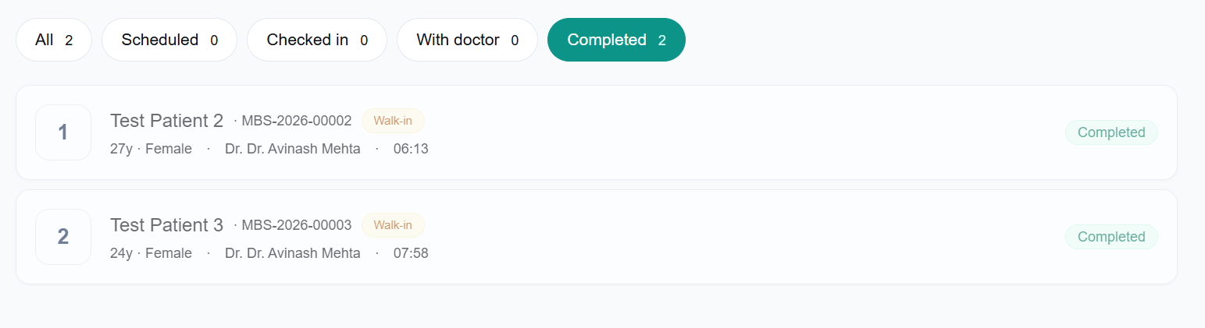  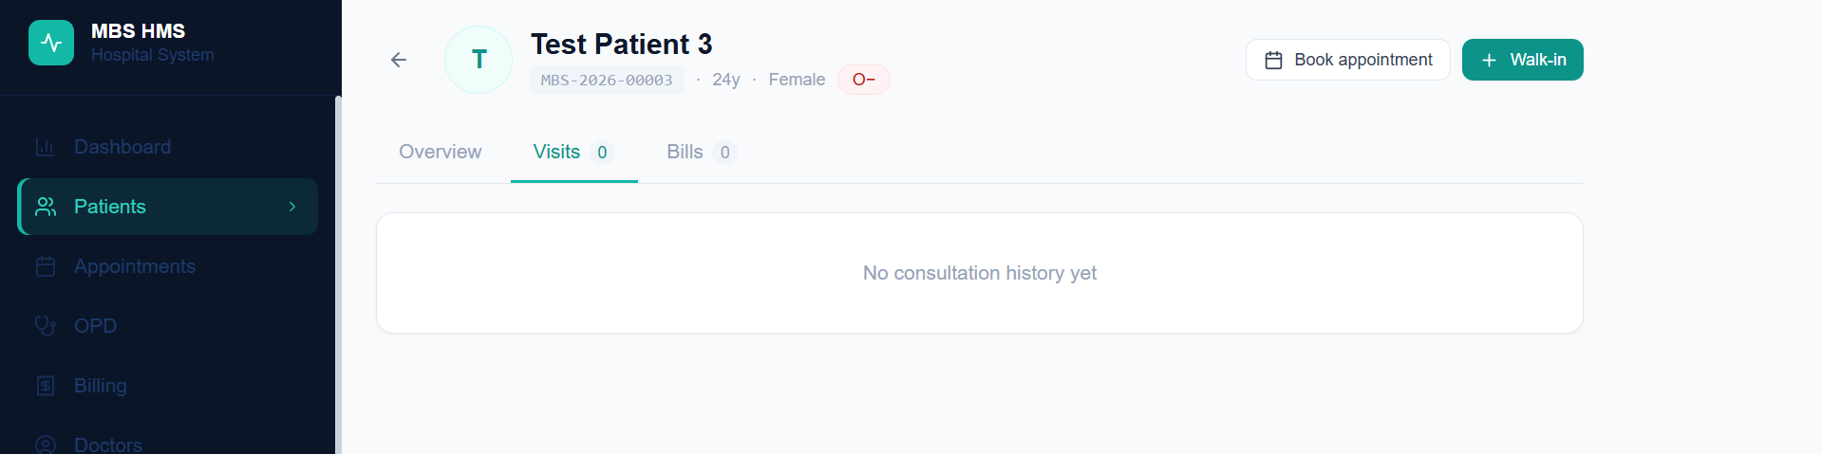
2.13 | View patient profile — bills tab | Open patient profile. Click the Bills tab. | Shows total billed, paid, and outstanding. List of bills if any exist. | FAIL | Billing Tab not active;
2.14 | Book appointment from patient profile | Open any patient profile. Click 'Book appointment' button. | Redirected to Book appointment page with patient pre-selected. | FAIL | Patient is not pre-selected  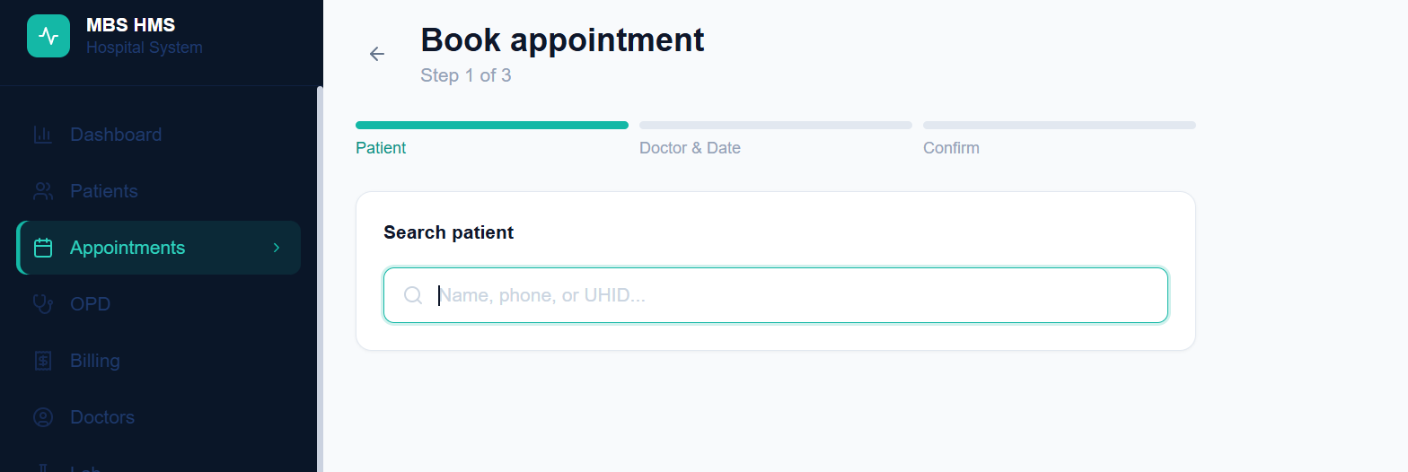

Module 3 — Doctor Management
Tests adding doctor profiles, setting schedules, and managing availability.

3A — Add Doctor
TC# | Test Case | Steps | Expected Result | Status | Notes
3.1 | Add doctor — Step 1 (create account) | Go to Doctors > Add doctor. Fill: Name (Dr. Test), Email (drtest@hospital.com), Phone (9876543211), Password (Doctor@123). Click Continue. | Step 1 completed. Progress bar moves to Step 2. | OK | OK
3.2 | Add doctor — Step 2 (medical profile) | Fill: Specialization (General Medicine), Qualification (MBBS), Consultation fee (500), Follow-up fee (300). Click Continue. | Step 2 completed. Progress bar moves to Step 3. | FAIL | I cannot move back from Step 2 to Step 1 while adding a new doctor
3.3 | Add doctor — Step 3 (schedule) | Enable Mon-Fri. Set 09:00 to 13:00 with 15 min slots. Click Save doctor. | Doctor created successfully. Redirected to doctors list. New doctor appears. | OK | OK
3.4 | Doctor appears in doctors list | Go to Doctors page. | Newly added doctor card shows: name, specialization, phone, fees, schedule days. | OK | OK
3.5 | Deactivate a doctor | On doctor card, click the toggle icon (right side). | Doctor shows as deactivated (card dims). Success message shown. | OK | We should change the color to red once a doctor is deactivated
3.6 | Reactivate a doctor | Click toggle again on a deactivated doctor. | Doctor reactivated. Card returns to normal. | FAIL | Doctor removed from doctor’s page after deactivating and refreshing the page
3.7 | Deactivated doctor not available for booking | Deactivate a doctor. Go to Book appointment. Select any patient. | Deactivated doctor does not appear in the doctor list. | OK | OK
Additional Notes/Observations:
- “Manage Doctor” Page is not there yet
- The doctor I deactivated earlier – is no more being shown in the doctor’s page after I refreshed the page. It should be there – but status is deactivated only

Module 4 — Appointments & Queue
Tests appointment booking, walk-in registration, and queue management — the core of daily reception operations.

4A — Book Scheduled Appointment
TC# | Test Case | Steps | Expected Result | Status | Notes
4.1 | Book appointment — search patient | Go to Appointments > Book appointment. Type patient name in search. Select patient from results. | Patient selected. Moved to Step 2 automatically. | OK | OK
4.2 | Book appointment — select doctor and slot | In Step 2, select an active doctor. Select today's date. Available slots appear. Click a green slot. | Slot highlighted. Continue button becomes active. | OK | Once a doctor is selected in the appointments page – her available days and time slots should appear – it is not appearing at present
4.3 | Book appointment — confirm | In Step 3, verify all details. Click Confirm appointment. | Appointment booked. Success message with token number. Redirected to queue. | OK | OK
4.4 | Already booked slot shows as unavailable | Book an appointment for a slot. Try to book the same doctor, same slot again. | That slot appears greyed out / unavailable. | OK | OK
4.5 | Doctor with no schedule shows no slots | Book appointment. Select a doctor who has no schedule set. Select any date. | Message: 'No slots available for this day.' | OK | OK

4B — Walk-In Registration
TC# | Test Case | Steps | Expected Result | Status | Notes
4.6 | Register walk-in patient | Go to Appointments > Walk-in. Search and select a patient. Select an active doctor. Click Register walk-in. | Walk-in registered. Token number assigned. Success message. Redirected to queue. | FAIL | Active doctor did not have today’s slot – yet walkin got registered
4.7 | Walk-in shows in queue with Walk-in badge | After registering walk-in, go to Appointments queue. | Walk-in patient appears with yellow 'Walk-in' badge and status 'Checked in'. | OK | OK
Note: For Walk-IN patients –
- The existing slots for any doctor chosen should be made visible
- “Doctor’s available today” should be shown while registering a walk-in patient
- Once a Doctor is selected from that “Doctor’s available today” – the available slots are to be shown for booking
4C — Queue Management
TC# | Test Case | Steps | Expected Result | Status | Notes
4.8 | View today's queue | Go to Appointments page. | All today's appointments listed with token numbers, patient name, UHID, age, doctor, time. | OK | We should also be able to see queues for any calendar date
4.9 | Filter queue by status | Click 'Scheduled', 'Checked in', 'With doctor', 'Completed' filter buttons. | Queue filters to show only that status. | OK | OK
4.10 | Check in a patient | Find a Scheduled appointment. Click 'Check in' button. | Status changes to 'Checked in'. Success message shown. | OK | OK
4.11 | Move patient to With doctor | Find a Checked in appointment. Click 'With doctor'. | Status changes to 'With doctor' (teal badge). | OK | OK
4.12 | Complete an appointment | Find a 'With doctor' appointment. Click 'Complete'. | Status changes to 'Completed' (green badge). Row dims slightly. | OK | OK
4.13 | Cancel an appointment | Find any non-completed appointment. Click the X/cancel icon. | Confirmation shown. On confirm, status changes to 'Cancelled'. | OK | OK
4.14 | Refresh queue | Click the refresh icon at top right of queue page. | Queue reloads with latest data. | OK | Can we also have the cancelled data shown somewhere?

Module 5 — OPD Consultation
Tests the doctor's consultation workflow — recording vitals, diagnosis, and prescription.

TC# | Test Case | Steps | Expected Result | Status | Notes
5.1 | OPD page shows checked-in patients | Ensure at least one appointment is in 'Checked in' or 'With doctor' status. Go to OPD. | Patient appears with token number, name, UHID, doctor name. | OK | OK
5.2 | Start consultation | Click 'Start consultation' next to a patient. | OPD consultation screen opens. Patient details shown at top with name, UHID, age, gender, blood group. | OK | OK
5.3 | Allergy warning visible | Open consultation for a patient who has allergies recorded. | Red alert with allergy details visible prominently at top. | OK | OK
5.4 | Record vital signs | In vitals section, fill BP (120/80), Pulse (72), Temperature (98.6), Weight (70), Height (170), SpO2 (98). Save. | Vitals saved without error. | OK | OK
5.5 | Record clinical notes | Fill Chief complaint, Symptoms, Clinical notes, Diagnosis fields. | All text fields accept input. No character limit errors. | OK | OK
5.6 | Set follow-up date | Select a follow-up date (any future date). | Date accepted. Will appear in patient visit history. | OK | OK
5.7 | Add prescription with one medicine | In prescription section, fill: Medicine name (Paracetamol 500mg), Dosage (500mg), Frequency (1-1-1), Duration (3 days). Click Complete. | Consultation saved. Prescription saved. Bill generated automatically. | FAIL | Error “Failed to Save”  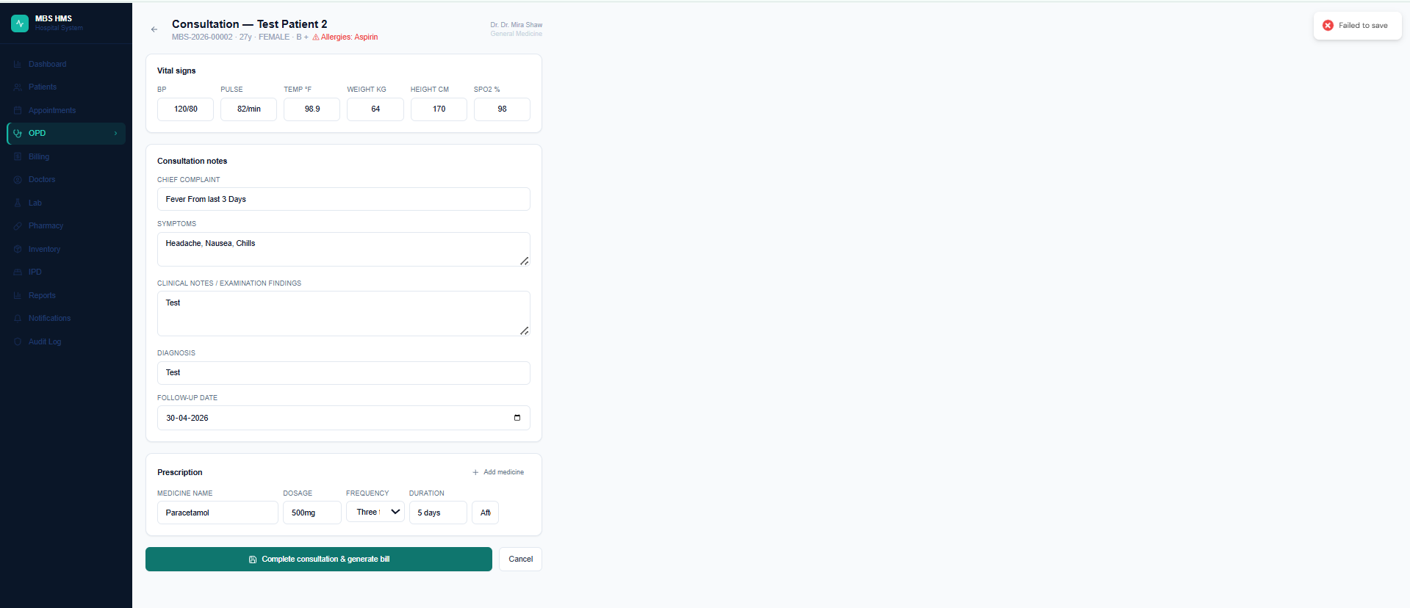
5.8 | Add prescription with multiple medicines | Click Add medicine. Add 3 different medicines with details. | All 3 medicines saved in prescription. | FAIL | FAIL
5.9 | Consultation completion updates queue | Complete a consultation. Go back to Appointments queue. | That appointment shows as 'Completed'. | FAIL | The consultation did not get saved – yet the patient appointment was being shown as “Completed”
5.10 | Completed consultation appears in patient history | Go to the patient's profile. Click Visits tab. | Visit appears with date, doctor name, diagnosis, and prescription medicines. | FAIL | Visit got updated for one patient but did not get updated for another. The one patient for whom the visit got update – we couldn’t save the OPD consultation form – error “Failed to Save” – yet the same form is being reflected in that patient’s visit

Module 6 — Billing & Payments
Tests bill generation (auto and manual), payment recording, and daily revenue summary.

6A — Auto-Generated Bill
TC# | Test Case | Steps | Expected Result | Status | Notes
6.1 | Bill auto-generated after consultation | Complete an OPD consultation via the OPD screen. | Bill automatically created in patient's Bills tab with consultation fee as line item. | FAIL | Bills is empty for all.
6.2 | Auto bill has correct amount | Check the auto-generated bill in patient profile > Bills tab. | Bill amount matches the doctor's consultation fee set in their profile. | FAIL | FAIL

6B — Billing Dashboard
TC# | Test Case | Steps | Expected Result | Status | Notes
6.3 | View billing summary | Go to Billing page. | Shows today's: Total billed, Collected, Pending amounts, and Collection rate percentage. | FAIL | Not getting updated
6.4 | Bills breakdown by status | Check the Billing page stats. | Shows count of: Fully paid, Partially paid, Unpaid bills for today. | FAIL | FAIL

6C — Patient Bills
TC# | Test Case | Steps | Expected Result | Status | Notes
6.5 | View patient bills | Go to any patient profile. Click Bills tab. | Shows total billed, paid, outstanding amounts. Lists all bills with bill number, date, type, amount, status. | FAIL | Not getting updated – consultation save failed
6.6 | Bill status shows correctly | Check a bill that was auto-generated but not paid. | Status shows as 'PENDING' in red badge. | FAIL | FAIL

Module 7 — Dashboard & Reports
Tests the owner's morning view — daily stats, queue status, and revenue overview.

TC# | Test Case | Steps | Expected Result | Status | Notes
7.1 | Dashboard loads with today's data | Log in and go to Dashboard. | Loads without error. Shows today's date. Greeting matches time of day (morning/afternoon/evening). | OK | OK
7.2 | Today's appointments count | Book 2 appointments. Go to Dashboard. | Today's patients counter reflects the booked appointments. | OK | OK
7.3 | Revenue stats update after consultation | Complete a consultation (which generates a bill). Go to Dashboard. | Today's billed amount reflects the consultation fee. | FAIL | FAIL – Billing not Reflected
7.4 | Queue status breakdown | Check the queue status section on Dashboard. | Shows correct counts for: Scheduled, Checked in, With doctor, Completed, Cancelled. | OK | The Queue section is fine – but the “Visits Completed” in the dashboard is reflecting only 2 completed visits whereas actually there were 3 visits completed. It seems like the”Visits Completed” section on captures visits against which OPD -> “Start Consultation” Button has been clicked. For the visits which has been simply marked “completed” from the appointments page – those are not reflected in “Visits Completed” Section. We need a fix for this entire thing  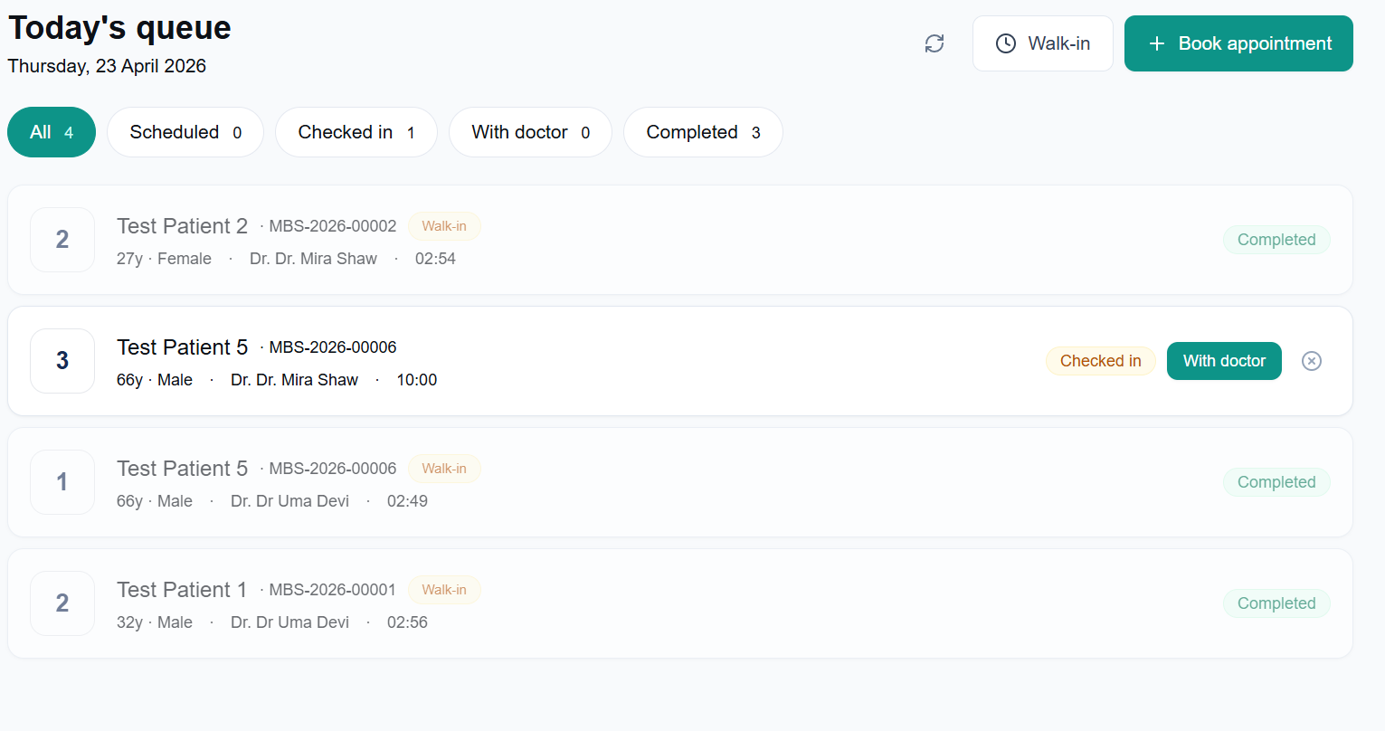
7.5 | Collection rate calculation | Dashboard shows collection rate. | Rate = (Collected / Billed) x 100. Shows as percentage. | FAIL | FAIL
7.6 | Active doctors count | Dashboard shows active doctors. | Count matches number of active doctors in the system. | OK | OK
7.7 | Quick actions work | On Dashboard, click each quick action button: Register patient, Book appointment, Walk-in token, Generate bill. | Each button navigates to the correct page. | FAIL | Generate Bill Page is not found 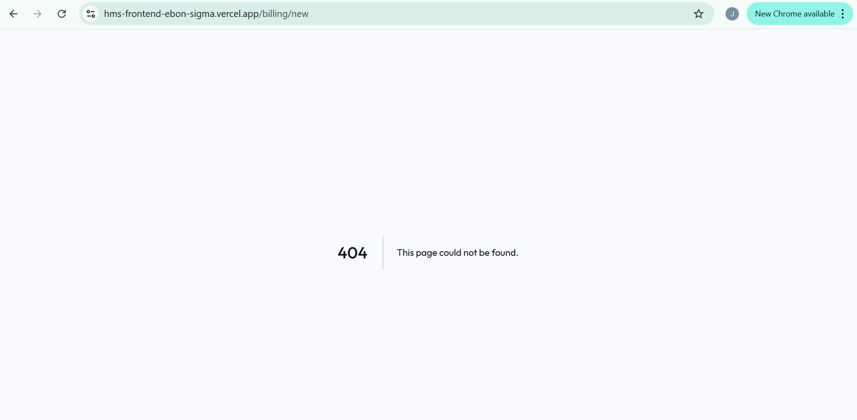
7.8 | System live indicator | Check top right of dashboard. | Green pulsing dot with 'System live' text visible. | OK | OK

Module 8 — Navigation & Layout
Tests that the sidebar, navigation, and layout work correctly across all pages.

TC# | Test Case | Steps | Expected Result | Status | Notes
8.1 | Sidebar visible on all main pages | Navigate to: Dashboard, Patients, Appointments, OPD, Billing, Doctors. | Sidebar visible on every page with navy background. | OK | OK
8.2 | Sidebar visible on sub-pages | Open a patient profile (/patients/[id]). Open Book appointment (/appointments/new). Open Walk-in page. | Sidebar visible on all these sub-pages. No double sidebar. | OK | OK
8.3 | Active page highlighted in sidebar | Navigate to each page. | Current page highlighted with teal left border and teal text in sidebar. | OK | OK
8.4 | Logo and brand visible | Check sidebar top. | Activity icon, MBS HMS text, and Hospital System subtitle visible. | FAIL | “Hospital System” subtitle font color to be changed to make it better readable
8.5 | User info in sidebar | Check sidebar bottom. | Logged in user's name and role visible. | OK | Font color change for better readability
8.6 | Page transitions | Navigate between different sections rapidly. | Pages load smoothly with subtle fade animation. | OK | OK
8.7 | Back button navigation | Open patient profile, then click back arrow. | Returns to patients list. | OK | OK
8.8 | Mobile sidebar (if applicable) | Open app on mobile browser or resize to mobile width. | Layout adapts. Content remains readable. | FAIL | FAIL 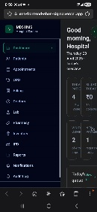

Module 9 — Security & Compliance
Tests DPDPA 2023 compliance features, HTTPS encryption, and audit trail.

TC# | Test Case | Steps | Expected Result | Status | Notes
9.1 | HTTPS / SSL active | Open https://api.sarvikatech.in/health in browser. | Padlock icon shows in browser. No 'Not secure' warning. Returns HMS health response. | FAIL | Success: False 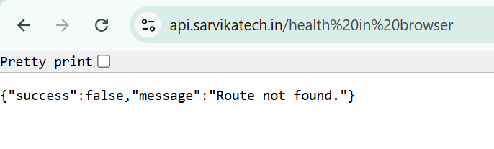
9.2 | Patient consent screen present | Go to Patients > Register patient. Scroll to bottom. | Consent section visible with DPDPA explanation and mandatory checkbox. Button disabled until consent ticked. | OK | OK
9.3 | Consent text is clear and complete | Read the consent text on registration form. | Mentions: data collection, healthcare purposes, hospital policy, DPDPA 2023. | OK | It mentions that “the Patient Verbally confirms” – is that okay?
9.4 | Login audit trail | Log in and out. (Audit logs viewable via API for now.) | Login and logout events recorded in audit_logs table. | FAIL | Audit Logs table not built yet
9.5 | Failed login recorded | Attempt login with wrong password. | Failed attempt logged to audit trail. | OK | OK
9.6 | Session expires after 8 hours | Note the login time. After 8 hours, try to access the app. | Session expired. Redirected to login page. | OK | OK
9.7 | Data stays in India | Verify the AWS region. | Backend deployed on AWS ap-south-1 (Mumbai). Confirmed by api.sarvikatech.in endpoint. | OK | OK

End-to-End Workflow Test
This is the most important test. Run it last, after all individual modules pass. It simulates a complete real hospital day.

TC# | Test Case | Steps | Expected Result | Status | Notes
E2E.1 | Add a doctor to the system | Go to Doctors > Add doctor. Add a doctor with Mon-Fri schedule, 09:00-13:00, 15 min slots, fee Rs.500. | Doctor created and visible in doctors list with schedule. | OK | OK
E2E.2 | Register a new patient | Go to Patients > Register patient. Register with name, phone, gender, blood group. Give consent. | Patient registered with UHID generated. | OK | OK
E2E.3 | Book an appointment | Go to Appointments > Book appointment. Select patient, select doctor, select today, pick a slot. Confirm. | Appointment booked. Token number assigned. Appears in today's queue. | OK | OK
E2E.4 | Check in patient at reception | In queue, find the appointment. Click Check in. | Status changes to Checked in. | OK | OK
E2E.5 | Move patient to doctor | Click With doctor on the checked-in appointment. | Status changes to With doctor. | OK | OK
E2E.6 | OPD consultation by doctor | Go to OPD. Click Start consultation. Fill vitals, diagnosis. Add one medicine. Complete. | Consultation saved. Bill auto-generated. Appointment marked completed. | FAIL | FAIL
E2E.7 | Verify patient history updated | Go to patient profile > Visits tab. | Visit appears with today's date, diagnosis, and prescription. | FAIL | FAIL
E2E.8 | Verify bill created | Go to patient profile > Bills tab. | Bill shows with correct amount (Rs.500). Status: Pending. | FAIL | FAIL
E2E.9 | Dashboard reflects the day's activity | Go to Dashboard. | Shows: 1 patient today, Rs.500 billed, 1 completed appointment. | FAIL | FAIL
E2E.10 | Walk-in patient flow | Go to Appointments > Walk-in. Register a different patient as walk-in to the same doctor. | Walk-in token generated. Patient appears in queue with Walk-in badge, status Checked in. | OK | OK

Bug Log
Record any issues found during testing here.

Bug# | Module | Description | Steps to Reproduce | Severity | Status
B001 | Authentication & Login | User name is Shown as MBS HMS - This needs to be different for different users – personalized – the Name | Code | High | Fixed
B002 | Authentication & Login | View current user profile - The font color can be made white – it’s less readable right now |  | Medium | Fixed
B003 | Patient Management | Can we make the “State” field as drop-down like blood group while registering a patient |  | High | Fixed
B004 | Patient Management | Duplicate phone number validation - 2 Patients with same phone number got saved   |  | Critical | Fixed
B005 | Patient Management | View patient profile — visits tab: I have tested by registering and completing an appointment with a patient – it is not getting reflected in the visits tab in patient profile. Although for Patient 2 – it is getting reflected in his visits tab but for patient 3 – it is not!     |  | Critical | Fixed
B006 | Patient Management | View patient profile — bills tab: Billing Tab not active |  | Critical | Fixed
B007 | Patient Management | Redirected to Book appointment page with patient pre-selected: Patient not pre-selected |  | Critical | Error
B008 | Doctor Management | Add doctor — Step 2 (medical profile): cannot move back from Step 2 to Step 1 while adding a new doctor. Also – if I cancel adding a doctor mid-way – the email id entered in Step 1 is retrieved somehow and I cannot re-add the doctor with that email ID  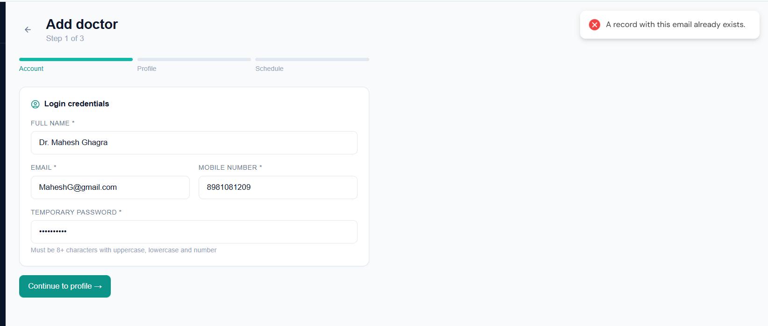 |  | Critical | Error
B009 | Doctor Management | Deactivate a doctor - We should change the color to red once a doctor is deactivated |  | Medium | Fixed
B010 | Doctor Management | “Manage Doctor” Page is not there yet |  | Critical | Error
B011 | Doctor Management | Once a doctor is deactivated and the page is refreshed – that doctor is no more shown on the doctor’s page | Can we add two tabs – active and not active doctors? | Critical | Error
B012 | Appointments & Queue - Book Scheduled Appointment | Book appointment — select doctor and slot: Once a doctor is selected in the appointments page – her available days and time slots should appear – it is not appearing at present |  | Critical
B013 | Appointments & Queue – Walk-In Registration | Register walk-in patient: Active doctor did not have today’s slot – yet walkin got registered | The existing slots for any doctor chosen should be made visible  “Doctor’s available today” should be shown while registering a walk-in patient  Once a Doctor is selected from that “Doctor’s available today” – the available slots are to be shown for booking | Critical | Error
B014 | Appointments & Queue – Queue Management | View today's queue: We should also be able to see queues for any calendar date – page not found |  | High | Error
B015 | Appointments & Queue – Queue Management | Cancel an appointment: Can we also have the cancelled data shown somewhere? |  | Medium | Fixed
B016 | OPD Consultation | Failed to Save: The consultation did not get saved – yet the patient appointment was being shown as “Completed” |  | Critical | Unknown
B017 | OPD Consultation | Completed consultation appears in patient history: Visit got updated for one patient but did not get updated for another. The one patient for whom the visit got update – we couldn’t save the OPD consultation form – error “Failed to Save” – yet the same form is being reflected in that patient’s visit |  | Critical | Fixed
B018 | OPD Consultation | Consultation completion updates queue: The consultation did not get saved – yet the patient appointment was being shown as “Completed” |  | Critical | Unknown
B019 | Billing & Payments | Only Dashboard without any numbers and all. The entire module is not functional and consultation is not getting saved. |  | Critical | Fixed
B020 |  | View patient bills: Not getting updated – consultation save failed |  | Critical | Fixed
B021 | Dashboard & Reports | Revenue stats update after consultation, Today's billed amount reflects the consultation fee: Billing not reflected in dashboard |  | Critical | Fixed
B022 | Dashboard & Reports | The “Visits Completed” in the dashboard is reflecting only 2 completed visits whereas actually there were 3 visits completed. It seems like the”Visits Completed” section on captures visits against which OPD -> “Start Consultation” Button has been clicked. For the visits which has been simply marked “completed” from the appointments page – those are not reflected in “Visits Completed” Section. We need a fix for this entire thing |  | Critical | Fixed
B023 | Dashboard & Reports | Dashboard shows collection rate: Not showing |  | Critical | Error
B024 | Dashboard & Reports | Quick actions work, On Dashboard, click each quick action button: Register patient, Book appointment, Walk-in token, Generate bill: Generate Bill Page is not found |  | Critical | Fixed
B025 | Navigation & layout | Logo and brand visible: Hospital System” subtitle font color to be changed to make it better readable |  | Medium | Fixed
B026 | Navigation & layout | Open app on mobile browser – FAIL   |  | Critical | Error
B027 | Security & Compliance | Open https://api.sarvikatech.in/health in browser: Success - False |  | High | Fixed
B028 | Security & Compliance | Log in and out. (Audit logs viewable via API for now.): Audit Logs are not built yet |  | Medium

UAT Sign-Off
To be completed after all test cases have been executed and reviewed.

Total Test Cases | 70
Passed | 42
Failed | 28
Blocked
Pass Rate | 60%
UAT Result | PASS / FAIL (circle one)
Tested by | Jotirmoy Majumder
Test Date | 23-04-26
Approved by | Jotirmoy Majumder
Approval Date | 23-04-26
Comments | Needs a lot of fixes

Signature: ___________________________ Date: _______________

By signing above, the tester confirms that all listed test cases have been executed and results accurately recorded.

Sarvika Technologies | sarvikatech.in | Confidential

